Experiment.No- 1B BASIC LINUX COMMANDS
- Basics
  - echo SRM - To display the string SRM
  - clear - To clear the screen
  - date -To display the current date and time
  - cal 2003 - to display the calender for the year 2003
Cal 6 2003 - to display the calender for the june-2003 5. passwd -To change password
- Working with Files
1.ls - list files in the present working directory ls –l -list files with detailed information (long list) ls –a - list all files including the hidden files
  - cat > f1 - to create a file (Press ^d to finish typing)
  - cat f1 - display the content of the file f1
  - wc f1 - list no. of characters, words & lines of a file f1 wc –c f1 - list only no. of characters of file f1 wc –w f1 -list only no. of words of file f1 wc –l f1 -list only no. of lines of file f1
  - cp f1 f2 - copy file f1 into f2
  - mv f1 f2 -rename file f1 as f2
  - rm f1 - remove the file f1
  - head –5 f1 - list first 5 lines of the file f1 tail –5 f1 - list last 5 lines of the file f1
- Working with Directories
  - mkdir elias -to create the directory elias
  - cd elias - to change the directory as elias
  - rmdir elias - to remove the directory elias
  - pwd -to display the path of the present working directory
  - cd -to go to the home directory cd .. - to go to the parent directory cd - -to go to the previous working directory cd / - to go to the root directory
- File name substitution
  - ls f? - list files start with ‘f’ and followed by any one character
  - ls *.c - list files with extension ‘c’
  - ls [gpy]et - list files whose first letter is any one of the character g, p or y and followed by the word et
  - ls [a-d,l-m]ring -list files whose first letter is any one of the character from a to d and l to m and followed by the word ring.
- I/O Redirection
1.Input redirection
wc –l < ex1 -To find the number of lines of the file ‘ex1’
2.Output redirection who > f2 - the output of ‘who’ will be redirected to file f2
3.cat >> f1 - to append more into the file f1
- Piping
Syntax : Command1 | command2
Output of the command1 is transferred to the command2 as input. Finally output of the command2 will be displayed on the monitor.
ex. cat f1 | more list the contents of file f1 screen by screen head –6 f1 |tail –2 prints the 5th & 6th lines of the file f1.
- Environment variables
  - echo $HOME -display the path of the home directory
  - echo $PS1 - display the prompt string $
  - echo $PS2 - display the second prompt string ( > symbol by default )
  - echo $LOGNAME - login name
  - echo $PATH -list of pathname where the OS searches for an executable file
- File Permission
-- chmod command is used to change the access permission of a file.
Method-1
Syntax : chmod [ugo] [+/-] [ rwxa ] filename u : user, g : group, o : others
+ : Add permission - : Remove the permission r : read, w : write, x : execute, a : all permissions ex. chmod ug+rw f1 adding ‘read & write’ permissions of file f1 to both user
and group members.
Method-2
Syntax : chmod octnum file1
The 3 digit octal number represents as follows
- first digit -- file permissions for the user
- second digit -- file permissions for the group -third digit -- file permissions for others
Each digit is specified as the sum of following
4 – read permission, 2 – write permission, 1 – execute permission ex. chmod 754 f1
it change the file permission for the file as follows
-read, write & execute permissions for the user ie; 4+2+1 = 7
-read, & execute permissions for the group members ie; 4+0+1 = 5
-only read permission for others ie; 4+0+0 = 4Experiment.No-1B Experiment.No-1C FILTERS and ADMIN COMMANDS
FILTERS
1.cut
- Used to cut characters or fileds from a file/input
Syntax : cut -cchars filename
-ffieldnos filename
-By default, tab is the filed separator(delimiter). If the fileds of the files are separated by
any other character, we need to specify explicitly by –d option
cut -ddelimitchar -ffileds filname
2.Grep
- Used to search one or more files for a particular pattern.
Syntax : grep pattern filename(s)
>Lines that contain the pattern in the file(s) get displayed
>pattern can be any regular expressions
>More than one files can be searched for a pattern
-v option displays the lines that do not contain the pattern
-l list only name of the files that contain the pattern
-n displays also the line number along with the lines that matches the pattern
3.Sort
-Used to sort the file in order
Syntax : sort filename
>Sorts the data as text by default
>Sorts by the first filed by default
-r option sorts the file in descending order
-u eliminates duplicate lines
-o filename writes sorted data into the file fname
-tdchar sorts the file in which fileds are separated by dchar
-n sorts the data as number
+1n skip first filed and sort the file by second filed numerically
4.Uniq
-Displays unique lines of a sorted file
Syntax : uniq filename
-d option displays only the duplicate lines -c displays unique lines with no. of occurrences.
5.Diff
- Used to differentiate two files
Syntax : diff f1 f2 compare two files f1 & f2 and prints all the lines that are differed between f1 & f2.
Q1. Write a command to cut 5 to 8 characters of the file f1.
$ cut -c 5-8 f1
Q2. Write a command to display user-id of all the users in your system.. $ -d: -f1,3|etc|passwd
Q3. Write a command to check whether the user judith is available in your system or not. (use grep)
$ grep ‘^judith:’/etc|passwd
Q4. Write a command to display the lines of the file f1 starts with SRM.
$ grep ‘ ^SRM’ f1
Q5. Write a command to sort the file /etc/passwd in descending order $ sort -r|etc|passwd
Q6. Write a command to display the unique lines of the sorted file f21. Also display the number of occurrences of each line.
$ uniq -cf21 uniq -c f21\sort-nr
Q7. Write a command to display the lines that are common to the files f1 and f2.
$ comm -12 f1f2
Experiment.No-2 PROCESS CREATION USING FROK() and Usage of getpid()
getpid(),wait() functions
AIM:
To Write a program for process creation using fork() and usage of getpid(),getppid(), Wait() function.
ALGORITHM:
- Initialize: Call getpid() to get the parent PID
- Fork : Call fork() to display the current process 3. Error check: (pid<0): log error with error() and exit
4. Child path (pid==0):
-Fetch ID’s using getpid() and grtppid()
-Terminate Via exit(status)
5.Parent path(pid>0):
- call wait(&status) to pause until child completes and prevent zombie state. -read exit status and resume.
PROGRAM:
-Process creating using fork():
#include <stdio.h>
#include <sys/types.h> #include <unistd.h>
int main() { fork(); fork();
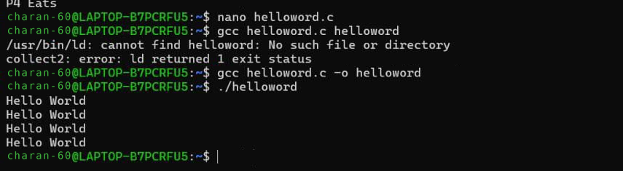
printf("Hello World\n"); return 0;
}
Output:
-Usage of getpid() and getppid():
#include <stdio.h>
#include <sys/types.h> #include <unistd.h>
int main() {
int process_id, p_process_id; process_id = getpid(); p_process_id = getppid();
printf("The process id: %d\n", process_id); printf("The process id of parent function: %d\n", p_process_id);
return 0;
}
Output:
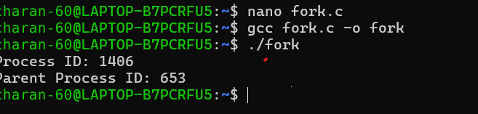
-Usage of wait():
#include <stdio.h>
#include <stdlib.h>
#include <sys/wait.h> #include <unistd.h>
int main() {
pid_t cpid;
if (fork() == 0) {
exit(0); // terminate child
} else { cpid = wait(NULL); // reaping parent / waiting for child
printf("parent pid = %d\n", getpid()); printf("childpid = %d\n", cpid);
}
return 0;
} Output:
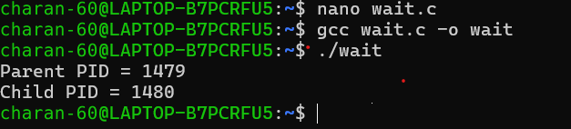
Result:
Thus successfully completed process creation using fork() and Usage of getpid(), getppid(),wait() functions.

Experiment.No-3 MULTITHREADING AND PTHREAD IN C
AIM:
To implement and study Multithreading and pthread in c
USE CASE: Distributed ground stations
ALGORITHM:(Single Processor)
- Start
- Include the required header files (pthread.h and stdio.h) * Define a thread function update_stock() that: * Receives the item name as input * Returns control to the calling thread * In the main() function:
- Declare a thread variable
- Create an array containing the stock update messages * Initialize a CPU set.
- Select CPU Core 0 for thread execution.
- Create a new thread to execute update_stock().
- Wait for the thread to complete using pthread_join(). * After all items are processed, terminate the program.
PROGRAM:
#include <stdio.h> #include <pthread.h>
int spo2; void *sensor(void *arg) {
printf("Thread 1: Reading SpO2 = %d%%\n", spo2); return NULL; }
void *monitor(void *arg) {
if (spo2 < 90)
printf("Thread 2: ALERT - Low SpO2!\n");
else
printf("Thread 2: SpO2 is Normal.\n");
return NULL; }
void *alert(void *arg) {
printf("Thread 3: Alert system checked.\n");
return NULL; }
int main() {
pthread_t t1, t2, t3; printf("Enter SpO2 level: "); scanf("%d", &spo2); pthread_create(&t1, NULL, sensor, NULL); pthread_create(&t2, NULL, monitor, NULL); pthread_create(&t3, NULL, alert, NULL); pthread_join(t1, NULL); pthread_join(t2, NULL); pthread_join(t3, NULL); printf("Monitoring completed.\n"); return 0;
}
OUTPUT:
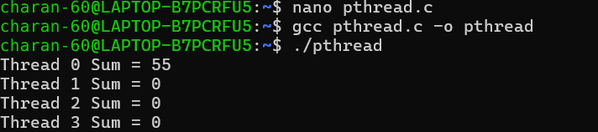
ALGORITHM:(Multi processor)
- Start
- Declare an array and variables for storing the sum.
- Create 4 threads using pthread_create().
- Divide the array into 4 parts.
- Each thread calculates the sum of its assigned part.
- Wait for all threads to finish using pthread_join().
- Add the sums calculated by all threads.
- Display the sum of each thread and the total sum.
- Stop
PROGRAM:
#include <stdio.h>
#include <pthread.h>
int spo2; pthread_mutex_t lock = PTHREAD_MUTEX_INITIALIZER;
void *sensor(void *arg) {
pthread_mutex_lock(&lock);
printf("Thread 1 [Sensor]: Current SpO2 reading = %d%%\n", spo2);
pthread_mutex_unlock(&lock);
return NULL; }
void *monitor(void *arg) {
pthread_mutex_lock(&lock); printf("Thread 2 [Monitor]: Status - "); if (spo2 >= 95 && spo2 <= 100) {
printf("NORMAL / SAFE (Healthy oxygenation)\n");
} else if (spo2 >= 90 && spo2 < 95) { printf("ACCEPTABLE / MILD LOW (Monitor closely)\n");
} else if (spo2 < 90 && spo2 >= 0) { printf("CRITICAL ALERT (Hypoxia risk - low SpO2!)\n");
} else { printf("INVALID READING (Enter value between 0-100)\n");
#include <math.h> long long S[1000001];
long long get_val(long long idx) {
long long l = 1, r =1000000, ans = 1; while (l <= r) {
long long m = (l+r) / 2; if (S[m] >= idx) { ans =m; r = m-1;} else l = m + 1; } return ans; }
int main() {
for (long long i = 1; i <= 1000000;i++) S[i] = S[i-1] + i * (long long)sqrt(i) + (i+1) / 2;
int Q; if (scanf("%d", &Q) == 1) {
while (Q--) {
long long L, R; scanf("%lld %lld", &L, &R);
printf("%lld\n",get_val(R) - get_val(L) + 1);
}
} return 0;
} }
pthread_mutex_unlock(&lock);
return NULL;
}
void *alert(void *arg) { pthread_mutex_lock(&lock);
if (spo2 < 90 && spo2 >= 0) {
printf("Thread 3 [Alert]: * TRIGGERING EMERGENCY ALARM *\n");
} else { printf("Thread 3 [Alert]: System nominal. No alarm triggered.\n");
}
pthread_mutex_unlock(&lock);
return NULL;
}
int main() { pthread_t t1, t2, t3;
printf("Enter SpO2 level (0-100%%): ");
if (scanf("%d", &spo2) != 1) { printf("Invalid input.\n");
return 1; }
pthread_create(&t1, NULL, sensor, NULL); pthread_create(&t2, NULL, monitor, NULL); pthread_create(&t3, NULL, alert, NULL);
pthread_join(t1, NULL); pthread_join(t2, NULL); pthread_join(t3, NULL);
pthread_mutex_destroy(&lock); printf("Monitoring completed.\n"); return 0;
}
OUTPUT:
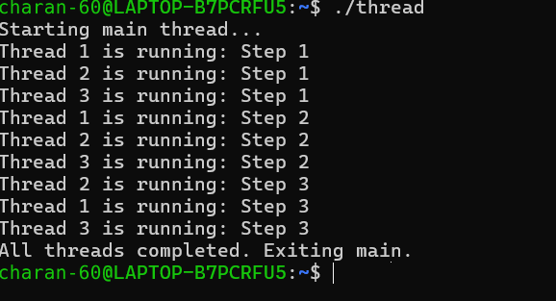

RESULT:
Sucessfully implemented and studied multithreading and pthread in c.
Experiment.No-4 MUTUAL EXCLUSION USING SEMAPHORE AND MONITOR
AIM:
To Implement mutual exclusion using semaphore and monitor.
USE CASE:Shared printer
ALGORITHM:(Mutual Exclusion)
- Spawn thread f_1 with argument ID = 1 to run land().
- Spawn thread f_2 with argument ID = 2 to run land().
- Wait for thread f_1 and thread f_2 to finish.
- Exit program.
Routine land(id):
- Lock mutex 'runway'.
- Print "Flight <id> Landing".
- Unlock mutex 'runway'.
- Terminate thread.
PROGRAM:
#include <stdio.h>
#include <pthread.h>

typedef struct {
int count;
pthread_mutex_t lock;
} Monitor;

Monitor mon = {0, PTHREAD_MUTEX_INITIALIZER};

void monitor_increment()
{
pthread_mutex_lock(&mon.lock);

mon.count++;
printf("Count: %d\n", mon.count);

pthread_mutex_unlock(&mon.lock);
}

void *worker(void *arg)
{
monitor_increment();
return NULL;
}

int main()
{
pthread_t t1, t2;

pthread_create(&t1, NULL, worker, NULL);
pthread_create(&t2, NULL, worker, NULL);

pthread_join(t1, NULL);
pthread_join(t2, NULL);

return 0;
OUTPUT:
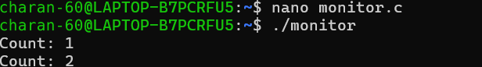
ALGORITHM:(Mutual Exclusion with Semaphore) • Start
1. Initialize the semaphore variables for the shared resources.
2. Create threads for the philosophers.
3. Each philosopher requests the required resources using wait().
4. Allow only one philosopher to enter the critical section at a time.
5. After eating, release the resources using signal().
6. In the monitor method, maintain the state of each philosopher as Thinking, Hungry, or Eating.
7. Check the left and right neighbours before allowing a philosopher to eat.
8. Ensure mutual exclusion and avoid deadlock.
9. Stop
PROGRAM:
#include <stdio.h>
#include <pthread.h> #include <semaphore.h>
char router_ip[16] = "192.168.1.1"; sem_t sem;
void* update_ip(void* arg) {
sem_wait(&sem); printf("Enter new Router IP: "); scanf("%15s", router_ip); printf("Updated IP: %s\n", router_ip);
sem_post(&sem); return NULL;
}
int main() {
sem_init(&sem, 0, 1); // Allow 1 thread at a time pthread_t t1, t2; pthread_create(&t1, NULL, update_ip, NULL); pthread_create(&t2, NULL, update_ip, NULL); pthread_join(t1, NULL); pthread_join(t2, NULL); sem_destroy(&sem); return 0;
}
OUTPUT:
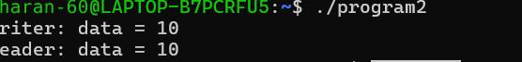
RESULT:
The program is successfullt executed.

Experiment.No-5 READER-WRITER PROBLEM
AIM:
To Study the Reader-Writer Problem .
USE CASE: Online Banking System
ALGORITHM:
Initialize lock: Create a shared mutex variable (to act as the gate keeper).
Spawn threads: Launch two separate airplane threads.
Critical Section: The winning thread points its landing message safely without interruption.
Release Mutex: The landing thread unlocks the runaway so the waiting thread can use it.
Join Threads: The main program waits for both airplane threads to finish before existing.
PROGRAM:
#include <stdio.h>
#include <pthread.h>
#include <semaphore.h>

int balance = 1000;
int readers = 0;

pthread_mutex_t mutex;
sem_t writeLock;

void *reader(void *arg)
{
pthread_mutex_lock(&mutex);
readers++;

if (readers == 1)
sem_wait(&writeLock);

pthread_mutex_unlock(&mutex);

printf("Reader %d: Balance = %d\n", *(int *)arg, balance);

pthread_mutex_lock(&mutex);
readers--;

if (readers == 0)
sem_post(&writeLock);

pthread_mutex_unlock(&mutex);

return NULL;
}

void *writer(void *arg)
{
sem_wait(&writeLock);

balance += 500;
printf("Writer: Deposited ₹500, New Balance = %d\n", balance);

sem_post(&writeLock);

return NULL;
}

int main()
{
pthread_t r[3], w;
int id[3] = {1, 2, 3};

pthread_mutex_init(&mutex, NULL);
sem_init(&writeLock, 0, 1);

for (int i = 0; i < 3; i++)
pthread_create(&r[i], NULL, reader, &id[i]);

pthread_create(&w, NULL, writer, NULL);

for (int i = 0; i < 3; i++)
pthread_join(r[i], NULL);

pthread_join(w, NULL);

pthread_mutex_destroy(&mutex);
sem_destroy(&writeLock);

return 0;
}OUTPUT:
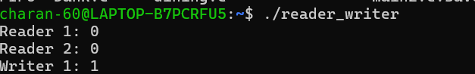
RESULT:
The Program is successfully executed.

Experiment.No-6 DINING-PHILOSOPHER PROBLEM
AIM:
To implement and study dining philosopher’s problem.
USE CASE: Traffic Junction managment
ALGORITHM:
- Initialization
Initialize an array of 3 mutex locks valve[0], valve[1], valve[2] to control watering valves. Define a thread identifiers array id = {0, 1, 2} representing three irrigation zones.
- Thread Creation
- Loop three times to create 3 concurrent worker threads t[0], t[1], and t[2], passing zone IDs 0, 1, and 2 respectively to the zone function.
- Zone Execution
Retrieve zone index i from the argument.
Lock own valve: Acquire mutex valve[i].
Unlock next valve: Release mutex valve[(i+1)%3].
- Termination
Wait for thread t[2] to complete using pthread_join(). Return 0 and exit.
PROGRAM:
#include <stdio.h>
#include <stdlib.h>
#include <pthread.h>
// Dynamic array for mutexes pthread_mutex_t* valve;
void* zone(void* a) { int i = *(int*)a;
pthread_mutex_lock(&valve[i]); printf("Zone %d irrigating\n", i); pthread_mutex_unlock(&valve[i]);
return NULL;
}
int main(int argc, char* argv[]) {
int num_zones;
// Check if input was provided via command-line argument if (argc > 1) {
num_zones = atoi(argv[1]);
} else {
// Otherwise, prompt the user for input printf("Enter number of irrigation zones: ");
if (scanf("%d", &num_zones) != 1 || num_zones <= 0) { printf("Invalid number of zones.\n"); return 1;
}
}
// Allocate threads, IDs, and mutexes dynamically pthread_t* t = malloc(num_zones * sizeof(pthread_t)); int* id = malloc(num_zones * sizeof(int)); valve = malloc(num_zones * sizeof(pthread_mutex_t));
// Initialize mutexes for (int i = 0; i < num_zones; i++) {
pthread_mutex_init(&valve[i], NULL);
}
// Create threads for (int i = 0; i < num_zones; i++) { id[i] = i; pthread_create(&t[i], NULL, zone, &id[i]);
}
// Join threads for (int i = 0; i < num_zones; i++) {
pthread_join(t[i], NULL);
}
// Clean up memory and destroy mutexes for (int i = 0; i < num_zones; i++) {
pthread_mutex_destroy(&valve[i]);
}
free(t); free(id); free(valve);
return 0;
}
OUTPUT:
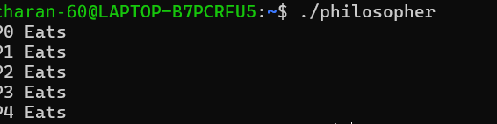
RESULT:
The program is successfully executed.

Experiment.No-7 BANKERS ALGORITHM THE DEADLOCK AVOIDANCE
AIM:
To Implement ans study Bankers algorithm for deadloack avoidance.
USE CASE:Airport Runway / Gate allocationSystem
ALGORITHM:(Program triggering deadlock)
- Lock Declaration: Initialize two global mutex locks; Lock-A and Lock-B.
- Thread 1 Execution:
Acquire Lock-A.
Pause execution briefly (sleep) to force a context switch.
Attempt to acquire Lock-B.
- Thread 2 Execution (Concurrent):
Acquire Lock-B.
Pause execution briefly (sleep) to force a context switch.
Attempt to acquire Lock-B (Note: written as Lock-B).
- Deadlock State: A Circular Wait Condition (Thread 1 \rightarrow Lock-B \rightarrow Thread 2 \rightarrow Lock-A \rightarrow Thread 1) forms, hanging the system.
PROGRAM:
#include <stdio.h>
#include <stdlib.h>
#include <pthread.h> #include <unistd.h>
// Global mutex locks
pthread_mutex_t l1 = PTHREAD_MUTEX_INITIALIZER; pthread_mutex_t l2 = PTHREAD_MUTEX_INITIALIZER;
// Global variable to store user-defined sleep duration (in seconds) int delay_sec = 1;
void* t1(void* a) { pthread_mutex_lock(&l1);
printf("[Thread 1] Acquired Lock 1. Waiting %d second(s)...\n", delay_sec); sleep(delay_sec);
printf("[Thread 1] Trying to acquire Lock 2...\n"); pthread_mutex_lock(&l2); // Deadlock point: t2 holds l2
printf("[Thread 1] Acquired Lock 2!\n"); pthread_mutex_unlock(&l2); pthread_mutex_unlock(&l1);
return NULL;
}
void* t2(void* a) { pthread_mutex_lock(&l2); printf("[Thread 2] Acquired Lock 2. Waiting %d second(s)...\n", delay_sec); sleep(delay_sec);
printf("[Thread 2] Trying to acquire Lock 1...\n"); pthread_mutex_lock(&l1); // Deadlock point: t1 holds l1
printf("[Thread 2] Acquired Lock 1!\n"); pthread_mutex_unlock(&l1); pthread_mutex_unlock(&l2);
return NULL;
}
int main() {
pthread_t a, b;
printf("Enter lock hold delay in seconds (e.g., 1 or 2): "); if (scanf("%d", &delay_sec) != 1 || delay_sec < 0) { printf("Invalid input. Defaulting to 1 second.\n");
delay_sec = 1;
}
// Create threads pthread_create(&a, NULL, t1, NULL); pthread_create(&b, NULL, t2, NULL);
printf("\nDeadlock triggered! System hanging...\n"); printf("(Press Ctrl+C in terminal to exit program)\n\n");
// Wait for threads (will hang indefinitely due to circular wait) pthread_join(a, NULL); pthread_join(b, NULL);
// Clean up locks (unreachable code due to deadlock)
pthread_mutex_destroy(&l1); pthread_mutex_destroy(&l2);
return 0;
}
OUTPUT:
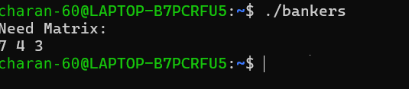

RESULT:
The program is executed successfully.
Experiment.No-8 FCFS AND SJF SCHEDULING
AIM:
To study the concepts of FCFS AND SJF scheduling.
USE CASE: Computer Lab / Server
ALGORITHM:(FCFS)
1.Initialize state: Set total cumulative and current running time to 0.
2.Sequential Processing: Process the drones in the exact order they arrive (no sorting required).
3.Calculate Waiting Times:
Assign and update running wait time for the next drone: w = w + t[i].
4,Compute Average:
Calculate Average Wait time = \frac{tw}{n}.
PROGRAM:
#include <stdio.h>
int main()
{ int n;
printf("Enter number of drones: "); scanf("%d", &n); float distance[n];
// Enter distances for (int i = 0; i < n; i++)
{ printf("Enter distance of Drone-%d: ", i + 1);
scanf("%f", &distance[i]);
} printf("\nDRONE WORK ASSIGNMENT - FCFS\n\n");
// Assign work according to FCFS for (int work = 1; work <= n; work++)
{ printf("Work-%d -> Drone-%d | Distance = %.2f\n", work, work, distance[work - 1]); }
return 0;
}
OUTPUT:
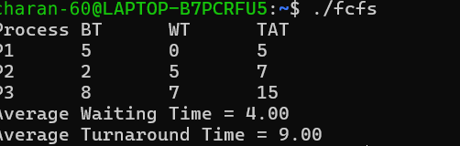
ALGORITHM:(SJF)
Initialize state:
Set total cumulative and current running time to 0.
Sort by Shortest Burst/Change Time (SJF selection):
Perform an in-place ascending sort on array t.
Whenever two elements t[i] and t[j] are swapped, swap the corresponding IDs in d.
Calculate Waiting Times:
Iterate through the sorted array from i = 0 to n-1.
Assign and update running wait time for next drone: w = w + t[i].
Compute Average:
Calculate Average Wait time = \frac{tw}{n}.
PROGRAM:
#include <stdio.h>
int main()
{ int n;
printf("Enter number of drones: "); scanf("%d", &n);
float distance[n]; int assigned[n];
// Enter distances for (int i = 0; i < n; i++)
{ printf("Enter distance of Drone-%d: ", i + 1); scanf("%f", &distance[i]);
assigned[i] = 0;
} printf("\nDRONE WORK ASSIGNMENT\n\n");
// Assign work according to shortest distance for (int work = 1; work <= n; work++)
{ float minDistance = 99999; int nearestDrone = -1;
for (int i = 0; i < n; i++)
{ if (assigned[i] == 0 && distance[i] < minDistance)
{ minDistance = distance[i]; nearestDrone = i;
}
} assigned[nearestDrone] = 1;
printf("Work-%d -> Drone-%d | Distance = %.2f\n", work, nearestDrone + 1, minDistance);
}
return 0;
}
OUTPUT:
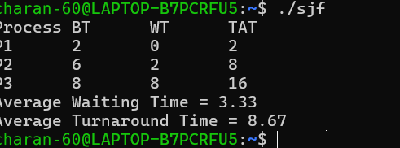.
RESULT:
The program are successfully executed.

Experiment.No-9 PRIORITY AND ROUND ROBIN SCHEDULING
AIM:
To Study the concept of priority and round robin scheduling.
USE CASE: smart traffic signal controller
PRIORITY SCHEDULING
ALGORITHM:
- Input & Validation
Input: The user specifies the number of tasks $n$ (constrained between 1 and 99).
Validation: If the input is invalid or exceeds bounds, the program terminates safely with an error message.
- Priority Assignment (getAutoPriority)
For each task entered, the program automatically assigns a priority score using a two-tier lookup rule:
Tier 1 (Predefined Routine): It performs a case-insensitive string comparison (strcasecmp / _stricmp) against a hardcoded array of standard college tasks (e.g., Exam = 1, Assignment = 2, Lecture = 3, etc.). If a match is found, it assigns its predefined rank.
Tier 2 (Custom Fallback): If the task is not in the predefined list, it assigns a priority rank after all standard tasks. It uses the ASCII value of the task's first letter (tolower(name[0]) - 'a') to give custom tasks a deterministic alphabetical fallback score.
- Sorting (Bubble Sort)
The program compares adjacent elements to arrange the tasks in ascending order of their priority scores (where lower numbers represent higher urgency):
It uses a nested loop structure to iterate through the array.
If a preceding task has a higher priority number (lower urgency) than a succeeding task (t[i].priority > t[j].priority), their positions and priority scores are swapped using a temporary temp struct.
- Output Generation
Finally, the sorted list of tasks is printed sequentially from top priority ($1$) to lowest priority ($n$).
#Complexity Analysis
Sorting: $O(n^2)$ due to the nested loop implementation of Bubble Sort.
Overall Time Complexity: $O(n^2)$ for small datasets ($n < 100$), which is efficient enough for this scale.
Space Complexity: $O(1)$ auxiliary space, as it operates entirely within a static global array of size $99$.
PROGRAM:
#include <stdio.h>
#include <string.h> #include <ctype.h>
struct Task { char name[30]; int priority;
}; struct Task t[99], temp;
/* Default college priority list (Lower number = Higher Urgency) */ const char *college_tasks[] = {
"Exam", // Priority 1
"Assignment", // Priority 2
"Lecture", // Priority 3
"Lab", // Priority 4
"Club", // Priority 5
"Gym", // Priority 6
"Hangout", // Priority 7
"Gaming" // Priority 8
}; int total_college_tasks = 8;
/* Automatically calculates priority rank for any task name */ int getAutoPriority(char name[]) {
// 1. Check if task matches typical college routine (case-insensitive)
for (int i = 0; i < total_college_tasks; i++) {
#if defined(_WIN32)
if (_stricmp(name, college_tasks[i]) == 0) return i + 1;
#else
if (strcasecmp(name, college_tasks[i]) == 0) return i + 1; #endif
}
// 2. Any custom/unknown activity gets ranked after standard routine return total_college_tasks + 1 + (tolower(name[0]) - 'a');
}
int main() { int n;
printf("Enter number of college tasks: "); if (scanf("%d", &n) != 1 || n <= 0 || n > 99) { printf("Invalid input.\n");
return 1; }
for (int i = 0; i < n; i++) { printf("Enter task %d: ", i + 1);
scanf("%29s", t[i].name);
// Auto-assign priority score
t[i].priority = getAutoPriority(t[i].name);
}
/* Sort tasks by priority order (1 = Top Priority) */
for (int i = 0; i < n; i++) {
for (int j = i + 1; j < n; j++) {
if (t[i].priority > t[j].priority) {
temp = t[i]; t[i] = t[j]; t[j] = temp;
}
}
}
printf("\n--- Priority Order ---\n"); for (int i = 0; i < n; i++) { printf("%d. %s\n", i + 1, t[i].name);
}
return 0;
}
OUTPUT: 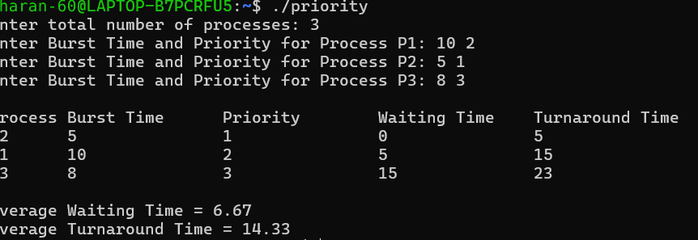

ROUND-ROBIN SCHEDULING
ALGORITHM:
- Initialization & Input
Inputs: The program reads the number of customers $n$ and the processing time (burst time) for each customer.
Setup: A fixed time quantum ($q = 2$ units) is established. The remaining array is initialized with the same values as the burst times to track how much processing each customer still needs.
- Round Robin Execution Loop (while (completed < n))
The program continuously loops through the customer queue until every customer's processing requirement is fully satisfied (completed == n).
- Time Slice Allocation
For each customer in the queue:
Check Status: It checks if the customer still has remaining processing time (remaining[i] > 0).
Completion Check: If the remaining time is less than or equal to the time quantum ($q$), the customer finishes their checkout. Their remaining time drops to 0, and the completed counter increments by $1$.
Partial Allocation: If the remaining time is greater than $q$, the customer is served for $q$ units, their remaining time is reduced by $q$, and the loop moves on to the next customer.
- Termination
Once all customers hit a remaining time of $0$, the while loop terminates, and a final completion message is displayed.

## Complexity Analysis
Time Complexity: $O(T / q \cdot n)$, where $T$ is the total sum of all processing times, $q$ is the time quantum ($2$), and $n$ is the number of customers. The loop runs for a number of cycles proportional to how many time slices are needed to clear the queue.
Space Complexity: $O(n)$ auxiliary space to store the burst and remaining arrays (sized statically up to $20$ elements).
PROGRAM:
#include <stdio.h>
int main() {
int n, q = 2, completed = 0;
int burst[20], remaining[20];
printf("Enter number of customers: "); scanf("%d", &n);
/* Enter processing time for each customer */
for (int i = 0; i < n; i++) { printf("Enter processing time for Customer %d: ", i + 1); scanf("%d", &burst[i]);
remaining[i] = burst[i];
}
printf("\nTime Quantum = %d units\n", q); printf("\n--- Round Robin Scheduling ---\n");
while (completed < n) { for (int i = 0; i < n; i++) { if (remaining[i] > 0) {
if (remaining[i] <= q) {
printf("Customer %d gets %d units and completes checkout.\n",
i + 1, remaining[i]);
remaining[i] = 0; completed++;
} else {
printf("Customer %d gets %d units. Remaining: %d units.\n", i + 1, q, remaining[i] - q);
remaining[i] -= q;
}
}
}
} printf("\nAll customer checkouts completed fairly!\n");
return 0;
}
OUTPUT:

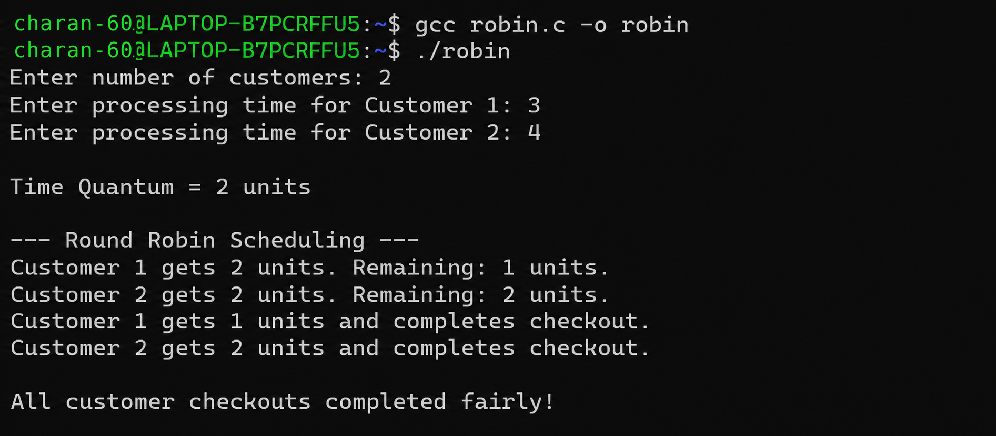
RESULT:
The Program is successfully executed.
Experiment.No-10 FIFO Page replacement Algorithm
Aim:
To implement FIFO page replacement algorithm.
1.What is FIFO ?
Ans: FIFO (First In, First Out) is a method in which the element that enters the system first is removed or processed first. It follows the same principle as a queue, where the person who comes first is served first. In FIFO, elements are handled in the order they arrive. It is simple and easy to implement. FIFO is commonly used in queues, CPU scheduling, and page replacement.
2.What a FIFO worker does?
Ans: A FIFO worker processes tasks in the same order in which they arrive. The worker takes the first task from the queue, completes it, and then moves to the next task. It does not skip tasks or change their order. This ensures fair and organized processing. For example, if tasks A, B, and C arrive in that order, the worker processes A → B → C.
3.What is FIFO page replacement algorithm?
Ans:FIFO (First In, First Out) Page Replacement Algorithm is a memory management technique used in Operating Systems. When a page fault occurs and all memory frames are full, the page that has been in memory for the longest time is removed. The newly required page is then loaded into the empty frame. It follows the first-in, first-out principle, similar to a queue. FIFO is simple to implement, but it may sometimes cause more page faults even when more frames are available.
USE CASE: Mobile Memory Management
ALGORITHM:
1.Start the program.
2.Declare apps, memory array m[3], pos, faults, and other required variables. Initialize the three memory frames to -1.
3.Read the number of apps from the user.
4.Repeat the process for apps × 2 times.
5.Generate the page number using (i % apps) + 1.
6.Check whether the page is already present in any of the three memory frames.
7.If the page is present, display that the page is already loaded.
8.If the page is not present, replace the oldest page using the FIFO method.
9.Update the FIFO position and increment the page fault count.
10.Display the total number of page faults and stop the program.
PROGRAM:
#include <stdio.h>
int main() {
int apps, m[3] = {-1,-1,-1}, pos = 0, faults = 0, j;
if (printf("Enter number of apps: ") && scanf("%d", &apps)) printf("\nMobile Memory Management\n");
for (int i = 0, p, f; i < apps * 2; i++) { for (p = (i % apps) + 1, f = 0, j = 0; j < 3; j++) if (m[j] == p) f = 1;
!f ? m[pos] = p, pos = (pos + 1) % 3, faults++, printf("App Page %d -> Replaced\n", p) :
printf("App Page %d ->>
}
return printf("\nTotal Page Faults = %d\n", faults), 0;
}
OUTPUT:
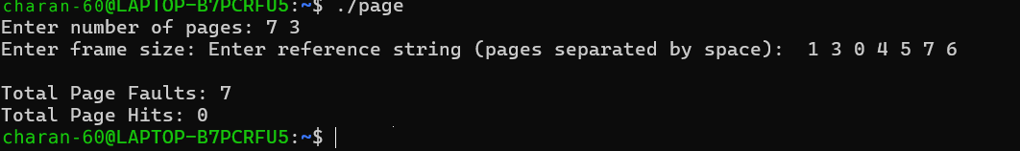

RESULT:
The Program is successfully executed

Experiment.No.11 LRU and LFU Page Replacement Algorithms.
Aim:
To implement page replacement using LRU and LFU .
Definitions:
1. What is LRU?
Answer:
LRU (Least Recently Used) is a page replacement algorithm used in Operating Systems. It replaces the page that has not been used for the longest period of time.
Example:
If the pages in memory are:
1 2 3
and page 1 was used a long time ago while pages 2 and 3 were recently used, then page 1 will be replaced when a new page arrives.
In short:
LRU = Replace the page that was used least recently.
2. What is LFU?
Answer:
LFU (Least Frequently Used) is a page replacement algorithm used in Operating Systems. It replaces the page that has been used the fewest number of times.
Example:
Page Number of times used
- 5
- 2
- 4
If a new page needs to be loaded, Page 2 will be replaced because it has been used the least number of times.
In short:
LFU = Replace the page that has been used the least frequently.
Difference between LRU and LFU
LRU LFU
Least Recently Used Least Frequently Used
Considers when a page was last used Considers how many times a page was used
LRU LFU
Replaces the page not used for the longest Replaces the page with the lowest usage time count
Use Case:
Online Food Delivery App
An online food delivery application stores recently accessed restaurant/menu pages in memory. Since memory is limited, only a few restaurant pages can remain in memory.
- LRU: Removes the restaurant page that was least recently accessed.
- LFU: Removes the restaurant page that was accessed the fewest times.
- Same use case: Online Food Delivery App.

Part A — LRU Page Replacement
Use Case:
Online Food Delivery App – Least Recently Used Restaurant Page
When a customer opens different restaurant pages and memory becomes full, the application removes the restaurant page that has not been accessed for the longest time.
Programmatic Algorithm
- Start.
- Initialize three memory frames as empty.
- Read the restaurant page reference string.
- Check whether the requested restaurant is already in memory.
- If present, update its recent-use time.
- If absent, generate a page fault.
- If an empty frame exists, load the restaurant page.
- Otherwise, find the least recently used page.
- Replace it with the new restaurant page.
- Display frames and total page faults.
- Stop.
Program:
#include<stdio.h>
int main(){int f[3]={-1,-1,-1},t[3]={0},r[]={1,2,3,1,4,2,5},i,j,p,k=0,fault=0,m;
for(i=0;i<7;i++){p=r[i];
for(j=0;j<3;j++)if(f[j]==p)
break;
if(j==3){fault++;m=0;
for(j=1;j<3;j++)
if(t[j]<t[m])m=j;f[m]=p;}
for(j=0;j<3;j++)if(f[j]==p)t[j]=++k;
printf("Restaurant %d: ",p);
for(j=0;j<3;j++)
printf("%d ",f[j]);printf("\n");}
printf("Page Faults=%d\n",fault);
return 0;}
Output:

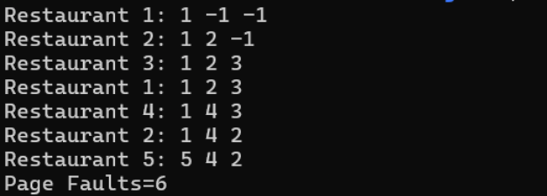

Part B — LFU Page Replacement
Use Case:
Online Food Delivery App – Least Frequently Used Restaurant Page
The application keeps frequently visited restaurant pages in memory. When memory is full, the restaurant page with the lowest access frequency is replaced.
Programmatic Algorithm:
- Start.
- Initialize three memory frames and frequency counters.
- Read the restaurant page reference string.
- Check whether the requested restaurant is present.
- If present, increment its frequency.
- If absent, generate a page fault.
- If an empty frame exists, load the restaurant page.
- Otherwise, find the page with the lowest frequency.
- Replace it with the requested restaurant page.
- Display frames and total page faults.
- Stop.

Program:
#include<stdio.h>
int main(){int f[3]={-1,-1,-1},c[3]={0},r[]={1,2,3,1,4,2,5},i,j,p,pos,min,fault=0;
for(i=0;i<7;i++){p=r[i];
for(j=0;j<3;j++)if(f[j]==p)
break;
if(j<3)c[j]++;
else{fault++;pos=0;
for(j=0;j<3;j++)
if(f[j]==-1){pos=j;break;}
if(f[pos]!=-1){min=c[0];pos=0;
for(j=1;j<3;j++)
if(c[j]<min)min=c[j],pos=j;}f[pos]=p;c[pos]=1;}
printf("Restaurant %d: ",p);
for(j=0;j<3;j++)
printf("%d ",f[j]);
printf("\n");}
printf("Page Faults=%d\n",fault);
return 0;}

Output:
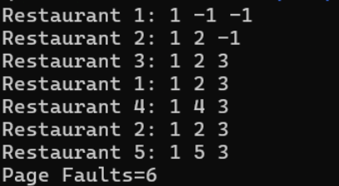

Result:
Successfully implemented page replacement using LRU and LFU algorithms

Experiment.No.12 Bestfit and Worstfit Memory Management Policies
Aim:
To implement and study Best fit and worst fit memory management policies in C .
Definations:
- What is Best Fit?
Answer:
Best Fit is a memory allocation technique in Operating Systems. It allocates a process to the smallest available memory block that is large enough to hold the process.
Example:
Available blocks: 100 KB, 500 KB, 200 KB, 300 KB
Process size: 180 KB
Best Fit chooses 200 KB, because it is the smallest block that can accommodate 180 KB.
In short:
Best Fit → Choose the smallest suitable memory block.
- What is Worst Fit?
Answer:
Worst Fit is a memory allocation technique that allocates a process to the largest available memory block.
Example:
Available blocks: 100 KB, 500 KB, 200 KB, 300 KB
Process size: 180 KB
Worst Fit chooses 500 KB, because it is the largest available block.
In short:
Worst Fit → Choose the largest available memory block.

Use Case:
Smart Hospital Patient Monitoring System
A smart hospital server dynamically loads different patient-monitoring modules such as ECG Monitoring, Patient Records, Blood Pressure Analysis, and Emergency Alert Processing. The operating system must allocate available memory blocks to these modules efficiently.
Given Memory Blocks
100 KB, 500 KB, 200 KB, 300 KB, 600 KB
Module Requests
212 KB, 417 KB, 112 KB, 426 KB

Part A — Best Fit
Definition
Best Fit allocates each module to the smallest available memory block that is large enough to accommodate it.
Programmatic Algorithm:
- Start.
- Read the available memory blocks and module sizes.
- For each module, search all available blocks.
- Select the smallest block that is large enough for the module.
- Allocate the module to that block.
- Reduce the remaining size of the selected block.
- Repeat for all modules.
- Display the allocation.
- Stop.
.
Program:
#include <stdio.h>
int main(){
int b[]={100,500,200,300,600},p[]={212,417,112,426},i,j,k;
for(i=0;i<4;i++){
k=-1;
for(j=0;j<5;j++)
if(b[j]>=p[i]&&(k<0||b[j]<b[k])) k=j;
if(k>=0){printf("M%d -> B%d\n",i+1,k+1);b[k]-=p[i];}
else printf("M%d -> Not Allocated\n",i+1);
}
}

Output:
Part B — Worst Fit
Definition:
Worst Fit allocates each module to the largest available memory block that is large enough to accommodate it.
Programmatic Algorithm:
- Start.
- Read the available memory blocks and module sizes.
- For each module, search all available blocks.
- Select the largest block that is large enough for the module.
- Allocate the module to that block.
- Reduce the remaining size of the selected block.
- Repeat for all modules.
- Display the allocation.
- Stop.
Program:
#include <stdio.h>
int main(){
int b[]={100,500,200,300,600},p[]={212,417,112,426},i,j,k;
for(i=0;i<4;i++){
k=-1;
for(j=0;j<5;j++)
if(b[j]>=p[i]&&(k<0||b[j]>b[k])) k=j;
if(k>=0){printf("M%d -> B%d\n",i+1,k+1);b[k]-=p[i];}
else printf("M%d -> Not Allocated\n",i+1);
}
}

Output:

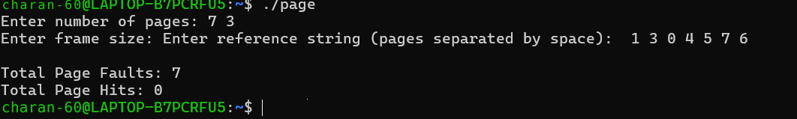

Result:
Successfully implemented and studied best fit and worst fit memory management policies in C

Experiment.No.13 Disk Scheduling Algorithm
Aim:
To implement and study disk scheduling algorithm
Definitions:
- What is Disk Scheduling?
Answer:
Disk Scheduling is the method used by an Operating System to decide the order in which disk I/O requests are serviced.
It decides which request the disk head should handle first.
Examples: FCFS, SSTF, SCAN, C-SCAN, LOOK.
- What is Disk Scheduling Needed For?
Answer:
Disk scheduling is needed to:
- Reduce seek time
- Reduce total head movement
- Improve disk performance
- Reduce waiting time
- Increase the number of requests processed per unit time (throughput)
- What is Seek Time?
Answer:
Seek time is the time taken by the disk's read/write head to move from its current track to the required track.
Example:
If the head is at track 50 and the required track is 100, the head must move 50 tracks.
In simple words:
Seek time = Time required to move the disk head to the required track.
- What is Total Head Movement?
Answer:
Total Head Movement is the total number of tracks traveled by the disk head while servicing all disk requests.
It is calculated by adding the distance moved between consecutive requests.
Example:
Head starts at 50 and requests are:
20 → 80 → 40
Total head movement:
|50 - 20| + |80 - 20| + |40 - 80|
= 30 + 60 + 40
= 130 tracks
In simple words:

Total Head Movement = Sum of all disk-head movements between requests.
Use Case – Hospital Medical Record Storage System
A hospital has a large database that continuously stores and retrieves patient medical records, X-ray images, and scan reports from a disk. Multiple storage requests are generated at different disk locations. The SSTF algorithm selects the request closest to the current disk-head position, reducing unnecessary head movement and improving the efficiency of storing and accessing medical records.
Programmatic Algorithm:
- Initialize the number of requests, disk-request array, current head position, and total_movement = 0.
- Mark all requests as unvisited.
- Display the current head position as the starting position.
- Search all unvisited requests and find the request with the minimum distance from the current head.
- Mark the selected request as visited.
- Add the calculated distance to total_movement.
- Move the disk head to the selected request.
- Repeat Steps 4–7 until all requests are serviced.
- Display the complete execution sequence.
- Display the total head movement.

Program:

#include <bits/stdc++.h>
using namespace std;
int main() {
int a[] = {82, 170, 43, 140, 24, 16, 190}, head = 50;
int n = 7, total = 0;
bool used[7] = {};
cout << "Sequence: " << head;
for (int k = 0; k < n; k++) {
int pos = -1, mn = INT_MAX;
for (int i = 0; i < n; i++)
if (!used[i] && abs(head-a[i]) < mn)
mn = abs(head-a[i]), pos = i;
used[pos] = true; total += mn; head = a[pos];
cout << " -> " << head;
}
cout << "\nTotal Head Movement = " << total << endl;
}
Output:

Result:
Successfully implemented various types of disk scheduling algorithm

Experimentno:14 Sequential and Indexed file Allocation

Aim : To implement and study Sequential and Indexed File Allocation

Definitions:

1. Sequential File Allocation
Sequential file allocation is a file allocation method in which all the blocks of a file are stored in consecutive (continuous) disk locations.
Example: If a file needs 4 blocks and starts at block 10, the blocks will be 10, 11, 12, 13.

2.Indexed File Allocation
Indexed file allocation is a file allocation method in which an index block stores the addresses of all the disk blocks belonging to a file. The file blocks do not need to be consecutive.
Example: If a file uses blocks 5, 12, 20, 35, the index block stores these block numbers and helps locate the file data.

Use Case – Online Movie Storage
An online movie streaming system stores a movie in consecutive disk blocks. Since the video is read sequentially from beginning to end, sequential allocation provides fast and efficient access to the movie data.

Programmatic Algorithm
- Read the starting block and number of blocks required.
- Start allocation from the given starting block.
- Allocate consecutive blocks for the movie.
- Store each allocated block number.
- Display the allocated blocks.
- Continue until all required blocks are allocated.
- Display the successful allocation status.

Program:
#include <stdio.h>
int main(){
int start,n,i;
printf("Enter start block and number of blocks: ");
scanf("%d%d",&start,&n);
printf("Movie blocks: ");
for(i=0;i<n;i++)
printf("%d ",start+i);
printf("\nMovie stored successfully.\n");
return 0;
}

Output:
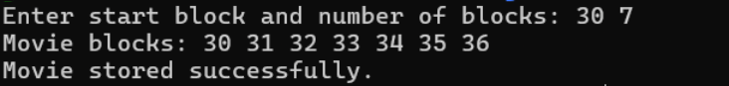

Use Case – Digital Library
A digital library stores different parts of an e-book in different disk blocks. An index block stores the addresses of these blocks, allowing the system to locate the required parts of the book easily.

Programmatic Algorithm:
- Read the number of blocks required for the e-book.
- Read the block numbers allocated to the e-book.
- Store the block numbers in an index block.
- Display the index block.
- Display all the referenced blocks.
- Use the index block to locate the e-book data.
- Display the successful allocation status.

Program:
#include <stdio.h>
int main(){
int n,b[20],i;
printf("Enter number of e-book blocks: ");
scanf("%d",&n);
printf("Enter block numbers: ");
for(i=0;i<n;i++) scanf("%d",&b[i]);
printf("Index block -> ");
for(i=0;i<n;i++) printf("%d ",b[i]);
printf("\nE-book stored successfully.\n");
return 0;
}
Output:
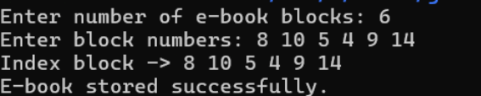

Result:

Successfully implemented and studied Sequential and Indexed File Allocation.

Experimentno:15 File Organization Schemes for Single and Two Level Directory

Aim :
To implement and study file organization schemes for single and two level directory

Definitions:
1. Single-Level Directory
A Single-Level Directory is a file organization scheme in which all files are stored in one common directory. Each file must have a unique file name because there is only one directory.
Example:
College
├── OS.txt
├── DSA.txt
├── Java.txt
└── Python.txt

2. Two-Level Directory
A Two-Level Directory is a file organization scheme in which each user has a separate directory to store their files. Different users can have files with the same name because they are stored in different directories.
Example:
College
├── Student1
│ ├── OS.txt
│ └── DSA.txt
│
└── Student2
├── OS.txt
└── Java.txt
Main difference:
- Single-Level: One common directory for all files.
- Two-Level: Separate directory for each user.

PART A — SINGLE-LEVEL DIRECTORY
Definition
A Single-Level Directory is a file organization scheme in which all files are stored in one common directory. Every file must have a unique name because there is only one directory.

Use Case: Hospital Patient Records
A hospital stores all patient record files in a single common directory. Each patient record is stored as a separate file. Since all files are in the same directory, duplicate file names are not allowed.

Programmatic Algorithm
- Start the program.
- Initialize an array to store file names.
- Display the menu.
- Choose Create File or View Files.
- For creating a file, enter the file name.
- Check whether the file already exists.
- If it exists, display an error message.
- Otherwise, store the file name.
- Display all files when View is selected.
- Stop when Exit is selected.

Program:
#include <stdio.h>
#include <string.h>

int main() {
char f[10][30], name[30];
int n=0, ch, i, found;

do {
printf("\n1.Create File 2.View Files 3.Exit\nChoice: ");
scanf("%d",&ch);

if(ch==1) {
printf("Enter patient file: ");
scanf("%s",name);
found=0;

for(i=0;i<n;i++)
if(strcmp(f[i],name)==0) found=1;

if(found) printf("File already exists!\n");
else {
strcpy(f[n++],name);
printf("File created successfully.\n");
}
}
else if(ch==2) {
printf("Patient Files:\n");
for(i=0;i<n;i++)
printf("%s\n",f[i]);
}
} while(ch!=3);

return 0;
}

Output:
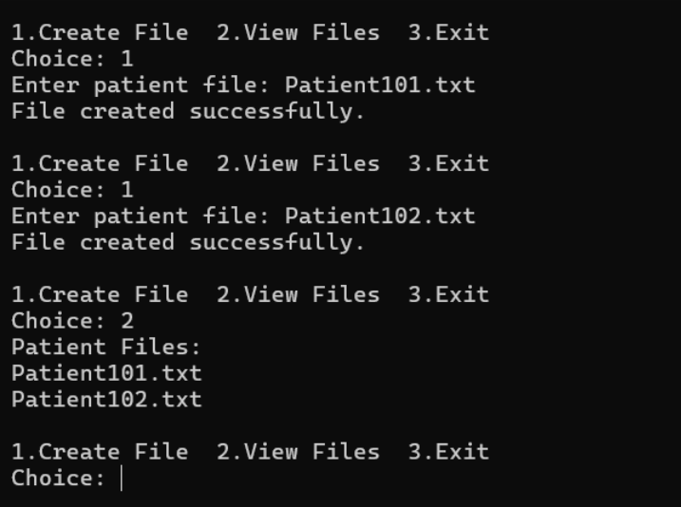

PART B — TWO-LEVEL DIRECTORY
Definition:
A Two-Level Directory is a file organization scheme in which each user has a separate directory for storing files. Different users can have files with the same name because their files are stored in different directories.

Use Case: Hospital Department Records
A hospital has different departments such as Cardiology and Neurology. Each department has its own directory to store patient records. The same file name can be used in different departments.

Programmatic Algorithm:
- Start the program.
- Initialize separate directories for two departments.
- Display the menu.
- Select a department.
- Enter the patient file name.
- Store the file in the selected department directory.
- Select View Files to display department records.
- Display all files of the selected department.
- Repeat until Exit is selected.
10 Stop the program.

Program:

#include <stdio.h>
#include <string.h>

int main() {
char f[2][5][20], name[20];
int n[2]={0,0}, d, ch, i;

do {
printf("\n1.Create File 2.View Files 3.Exit\nChoice: ");
scanf("%d",&ch);

if(ch==1) {
printf("Department (1-Cardiology, 2-Neurology): ");
scanf("%d",&d);
printf("Enter patient file: ");
scanf("%s",name);
strcpy(f[d-1][n[d-1]++],name);
printf("File created successfully.\n");
}
else if(ch==2) {
printf("Department (1-Cardiology, 2-Neurology): ");
scanf("%d",&d);
printf("Patient Files:\n");
for(i=0;i<n[d-1];i++)
printf("%s\n",f[d-1][i]);
}
} while(ch!=3);

return 0;
}

Output:

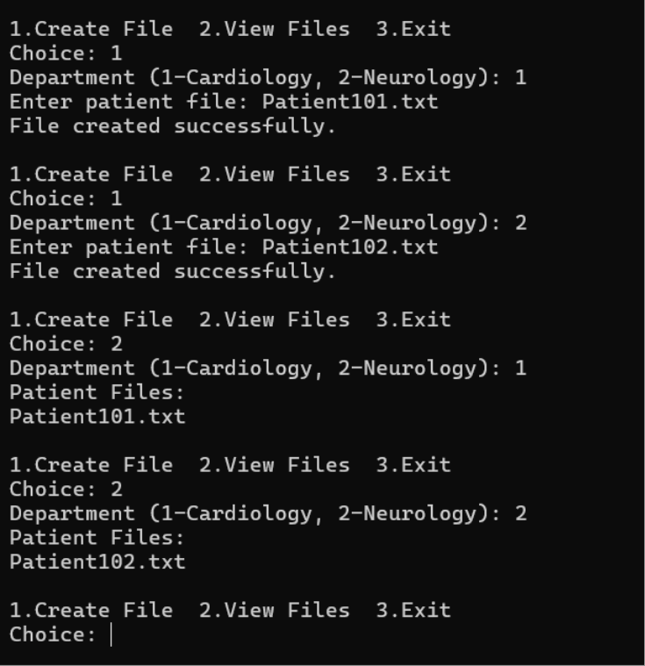

Result :
Successfully implemented file organization schemes for single level and two level directory

